**Boxing and Unboxing in C#:**

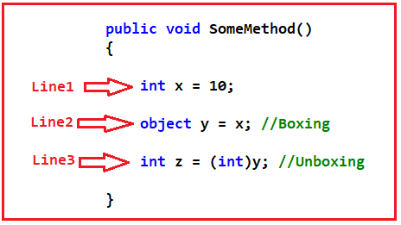

##### ****Line1: int x = 10;****

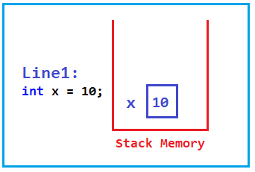

##### ****Line2: object y = x;****

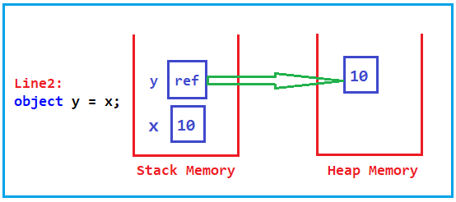

##### ****Line3: int z = (int)y;****

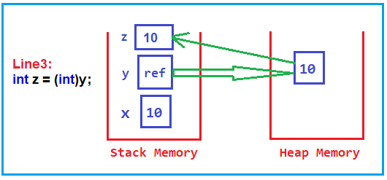

**Note:** Boxing means you basically set a value type to a reference type and unboxing means you basically set a reference type to a value type.

There is performance hit if we done boxing and unboxing excessively.